Modeling Tool Design
Version: | 0.1
Author(s): | JE
Created: | 04/20/2009
Last modification: | 05/14/2009

Version | Date | Author(s) | Changes
0.1 | 04/20/2009 | JE | Initial version.
Contents
1. The Client Side Modeling Tool – View Elements 2
1.1. Workflow Properties 2
1.2. Nodes and Containers 2
1.3. Node Selection and Resizing 3
1.4. Ports 3
1.5. Connections 4
1.6. Dialogs 4
2. The Client Side Modeling Tool – Model Elements 4
3. Commands 4
3.1. The Command Stack 4
3.2. Commands 5
4. The Interface 5
4.1. Reading and Writing the DWDL 5
4.2. Embedding in the Web Portal 5

The Client Side Modeling Tool – View Elements

The Workflow

Workflow, Nodes and Containers
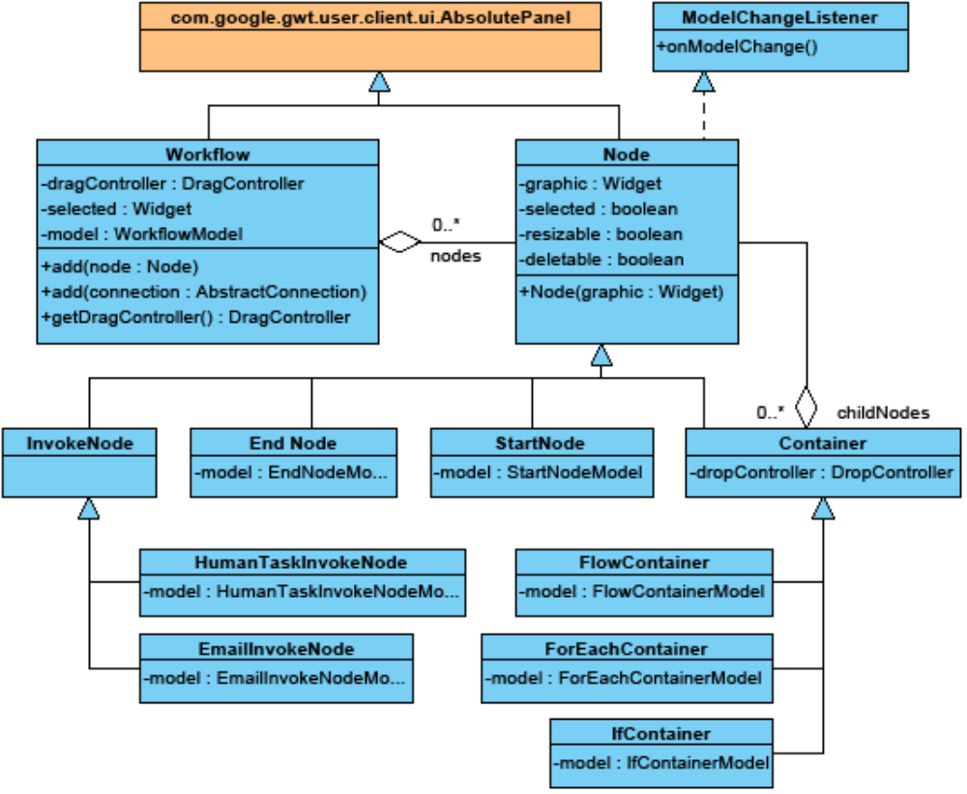
Figure 1: Class diagram of the workflow, nodes and containers.

Common attributes:
G model:
Each non-abstract node class and the workflow class has a model which holds the data of the node/workflow (see chapter 2). All these classes implement the ModelChangeListener interface. The containing method onModelChange() is called by the model class when any data changes. The getter is required to access the model data.

The Workflow class:
dragController:
A simple drag controller that makes all movable elements draggable to any location within the workflow panel. Every element added to the workflow has to be made draggable separately.
G S selectedWidget:
The selected widget in the workflow. This can be only one widget. Null, if no widget is selected. Getter and setter are required for reading and updating the value when the selection changes.
G nodes:
A list of all nodes in the workflow not included by a container. Nodes within a container are accessed through the parent container node.

The Node Class:
graphic:
The graphical representation of the node. Only settable by constructor.
G S selected:
True, if the node is the selected node. If this value is true, the selectedWidget attribute of the workflow must point to this node.
G movable:
True, if the node is movable. If this value is true, this node is made draggable during adding to a workflow, else not.
G resizable:
True, of the node is resizable (see chapter 1.3).
G deletable:
True, if the node can be deleted.

Node Selection and Resizing
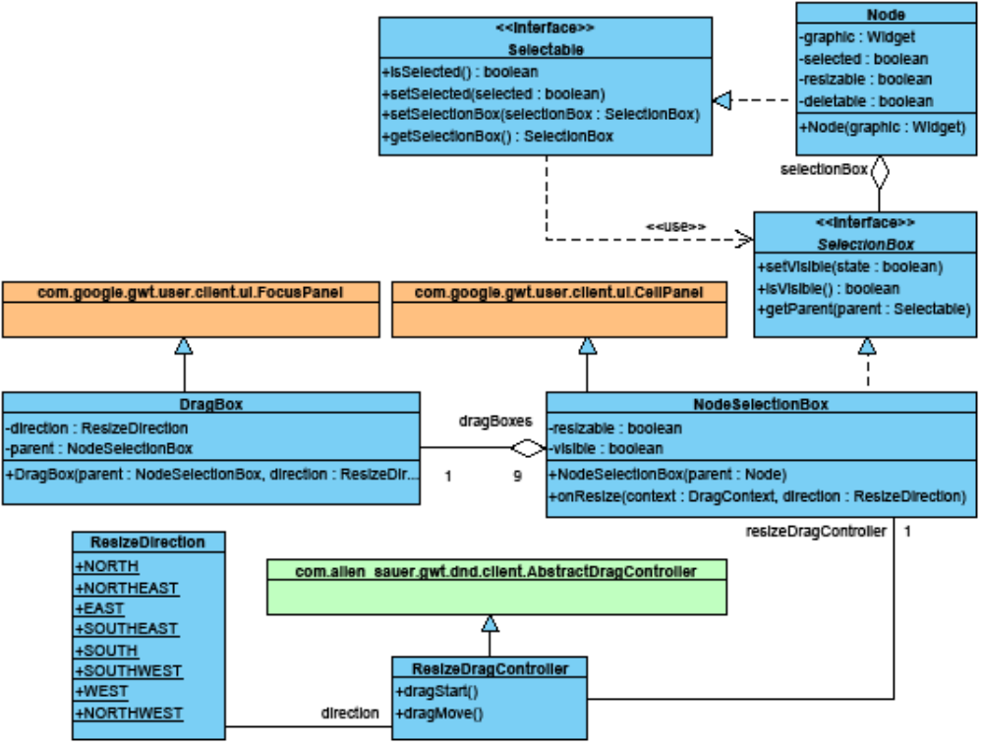
Figure 2: Class diagram of the node selection and resizing classes.

Ports
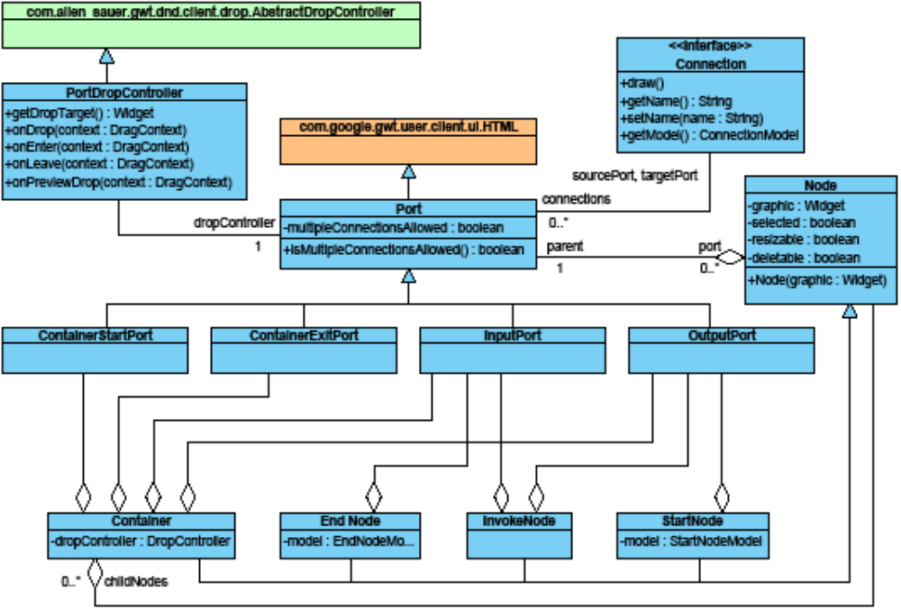
Figure 3: Class diagram of the port classes.

Connections
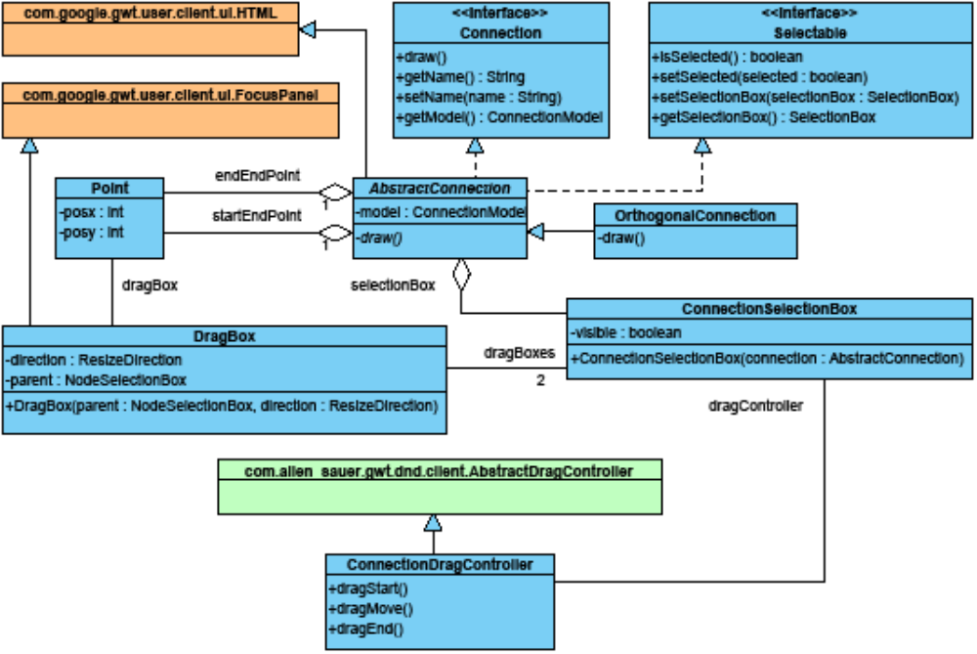
Figure 4: Class diagram of the connection and connection drag classes.

Property Windows

The Client Side Modeling Tool – Model Elements

Workflow Model

Node and Connection Models

Commands

The Command Stack
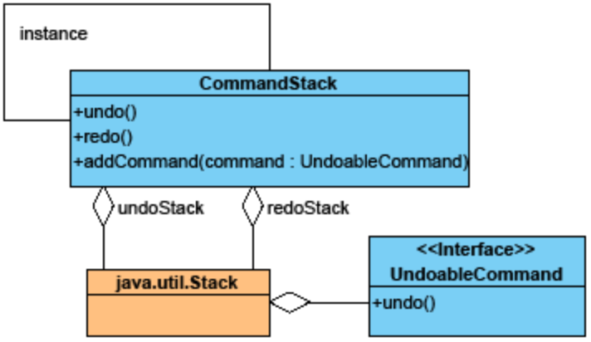
Figure 5: Class diagram of the command stack.

Commands
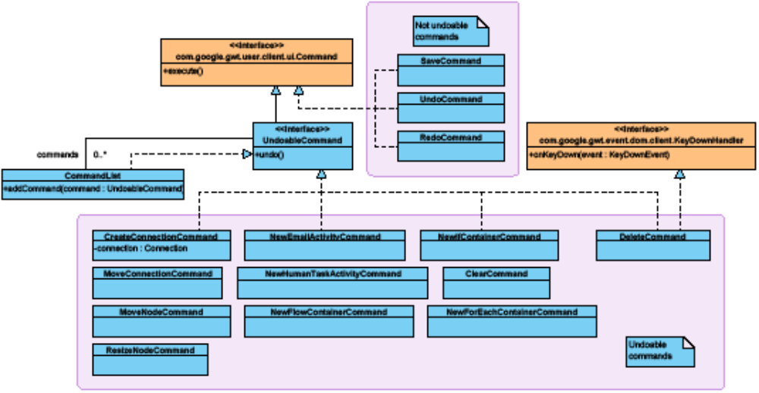
Figure 6: Class diagram of the command classes.

The Interface

Reading and Writing the DWDL

Embedding in the Web Portal

